

Foundations of Programming

Assignment No. : 06
PROBLEM STATEMENT:Write a C function to compute the factorial of a number with and without recursion.

OBJECTIVE:

To demonstrate two different approaches for calculating the factorial of a number: iterative (non-recursive) and recursive, showcasing the versatility of problem-solving methods in programming.

THEORY:

1) Difference between Iterative and Recursive Factorial
Aspect | Iterative Approach | Recursive Approach
Method | Uses loops (for/while) | Function calls itself
Logic | Repeated multiplication from 1 to n | Breaks problem into smaller subproblems
Memory Usage | Less (no function call stack) | More (uses call stack)
Speed | Faster | Slightly slower due to overhead
Complexity | Simple and efficient | More elegant but complex
Example:
- Iterative: fact = fact * i inside loop
- Recursive: fact(n) = n × fact(n-1)

2) Base Case in Recursive Factorial
The base case is:
factorial(0) = 1 or factorial(1) = 1
Why it is necessary:
- Stops infinite recursive calls
- Provides a termination condition
- Without it → program crashes due to stack overflow

3) Handling Invalid Input (Negative Numbers)
A good program checks:
if (n < 0)
printf("Factorial not defined for negative numbers");
Why this is important:
- Factorial is not defined for negative numbers
- Prevents incorrect output
- Avoids infinite recursion or logical errors
- Makes the program robust and user-friendly

PLATFORM: Linux
ALGORITHM:
1. Iterative Approach (Non-Recursive)
- Start.
- Initialize a variable fact = 1.
- Read the input number n.
- If n < 0, return an error (factorial is not defined for negative numbers).
- Loop: For each integer i from 1 to n:
  - Update fact = fact * i.
- Return fact.
- End.
2. Recursive Approach
- Start.
- Read the input number n.
- Base Case: If n == 0 or n == 1, return 1.
- Recursive Step: If n > 1, return n * factorial(n - 1).
- End.

FLOWCHART:
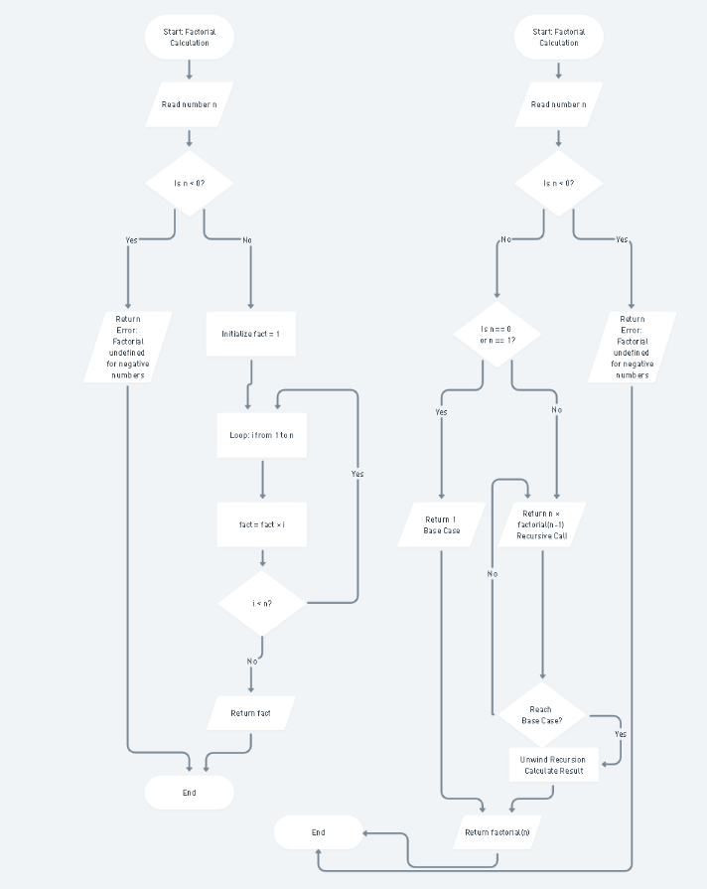
CODE:
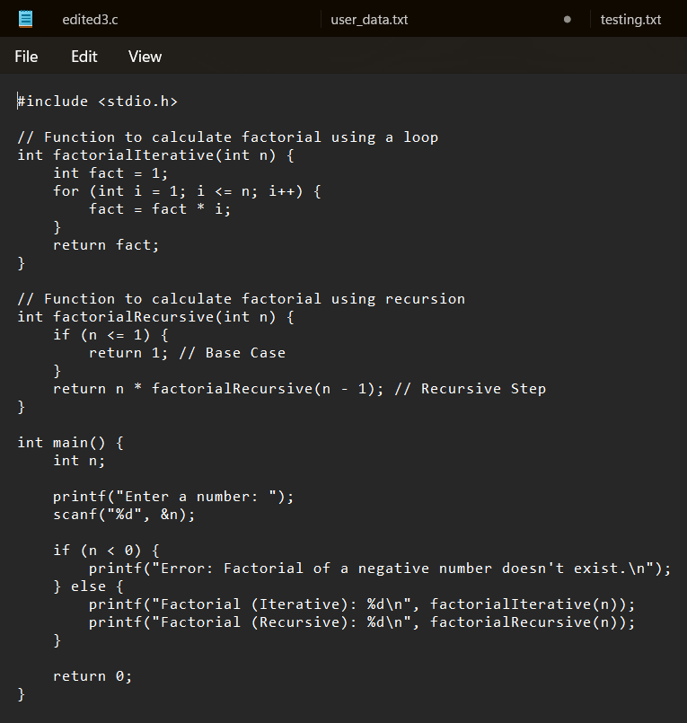

INPUT/OUTPUT:

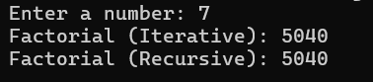
CONCLUSION: Thus, we have successfully executed factorial of a number with and without recursion.

FAQs:
1. What is the purpose of calculating factorial in programming?
2. What is the difference between recursive and non-recursive (iterative) methods?

